Appendix 1. Ecosystem and Socioeconomic Profile of the Blue King Crab stock in the St. Matthew Report Card

Erin Fedewa, Kalei Shotwell, Abby Tyrell

Draft 2023



*With Contributions from:*

Kalei Shotwell, Abby Tyrell

# Current Year Update

The ecosystem and socioeconomic profile, or ESP, is a standardized framework for compiling and evaluating relevant stock-specific ecosystem and socioeconomic indicators and communicating linkages and potential drivers of the stock within the stock assessment process (Shotwell et al., 2023). The ESP process creates a traceable pathway from the initial development of indicators to management advice and serves as an on-ramp for developing ecosystem-linked stock assessments.

Please refer to the last full ESP, partial, and report card documents (*list references*) which are available within the Blue King Crab stock assessment and fishery evaluation or SAFE reports for further information regarding the ecosystem and socioeconomic linkages for this stock.

## Management Considerations

Summary conclusions from ESP for ABC (risk table)

## Modeling Considerations

Summary of indicators with high importance in the Bayesian adaptive sampling routine and discussion of which indicators have had consistent high importance. List of research ecosystem model runs that are currently ongoing and potential for operational use in the future.

# Assessment

## Ecosystem and Socioeconomic Processes

One paragraph description of ecosystem and socioeconomic (if available) conceptual model(s)

## Indicator Suite

One paragraph description of LME level indicators relevant to stock (ESR summary)

### Ecosystem Indicators:

#### 1. Physical Indicators

1. Summer_Cold_Pool_SEBS_SMBKC_Survey: Summer cold pool extent (nmi) in Saint Matthews Island area from the AFSC eastern Bering Sea bottom trawl survey
   * Contact: Erin Fedewa
   * Status and trends: **Information not present in database**
   * Factors influencing trends: **Information not present in database**
   * Implications: **Information not present in database**
2. Summer_Temperature_Bottom_SMBKC_Survey: Summer bottom temperatures in the SMBKC management area from the AFSC EBS bottom trawl survey
   * Contact: Erin Fedewa
   * Status and trends: **Information not present in database**
   * Factors influencing trends: **Information not present in database**
   * Implications: **Information not present in database**
3. Spring_pH_SMBKC_Model: Spring pH index in St Matthews crab management area from the Bering10K ROMS-NPZ model
   * Contact: Darren Pilcher
   * Status and trends: **Information not present in database**
   * Factors influencing trends: **Information not present in database**
   * Implications: **Information not present in database**
4. Spring_Corrosivity_Index_SMBKC_Model: Spring corrosivity index in St Matthews Island crab management area from the Bering10K ROMS-NPZ model
   * Contact: Darren Pilcher
   * Status and trends: **Information not present in database**
   * Factors influencing trends: **Information not present in database**
   * Implications: **Information not present in database**
5. Summer_Wind_Stress_SMBKC_Satellite: Summer wind stress (m/s) in St Matthew Island crab management area from NOAA/NCDC blended winds and Metop-A ASCAT satellite
   * Contact: Kalei Shotwell
   * Status and trends: **Information not present in database**
   * Factors influencing trends: **Information not present in database**
   * Implications: **Information not present in database**

#### 2. Lower Trophic Indicators

1. Spring_Chlorophylla_Biomass_SMBKC_Satellite: Derived chlorophyll a concentration during spring in the St Matthews Island crab management area from the MODIS satellite
   * Contact: Matt Callahan
   * Status and trends: Low this year
   * Factors influencing trends: See latest Ecosystem Status Report.
   * Implications: **Information not present in database**
2. Summer_Benthic_Invertebrate_Density_SMBKC_Survey: Summer benthic invertebrate biomass in St Matthew Island from the AFSC eastern Bering Sea bottom trawl survey
   * Contact: Erin Fedewa
   * Status and trends: **Information not present in database**
   * Factors influencing trends: **Information not present in database**
   * Implications: **Information not present in database**

#### 3. Upper Trophic Indicators

1. Summer_Pacific_Cod_Density_SMBKC_Survey: Summer Pacific cod biomass in St Matthew Island crab management area from the AFSC EBS bottom trawl survey
   * Contact: Erin Fedewa
   * Status and trends: **Information not present in database**
   * Factors influencing trends: **Information not present in database**
   * Implications: **Information not present in database**
2. Annual_Blue_King_Crab_Pre_Recruit_Biomass_SMBKC_Model: Annual pre-recruit biomass from the SMBKC stock assessment model
   * Contact: Katie Palof
   * Status and trends: **Information not present in database**
   * Factors influencing trends: **Information not present in database**
   * Implications: **Information not present in database**
3. Annual_Blue_King_Crab_Recruit_Abundance_SMBKC_Survey: SMBKC recruit abundance was estimated from the EBS bottom trawl survey catch data
   * Contact: Jon Richar
   * Status and trends: **Information not present in database**
   * Factors influencing trends: **Information not present in database**
   * Implications: **Information not present in database**

### Socioeconomic Indicators:

#### 1. Fishery Performance Indicators

1. Annual_Blue_King_Crab_CPUE_SMBKC_Fishery: Annual catch-per-unit-effort (CPUE) (expressed as mean number of crabs per potlift) in the St Matthew Island blue king crab fishery
   * Contact: Brian Garber-Yonts
   * Status and trends: **Information not present in database**
   * Factors influencing trends: **Information not present in database**
   * Implications: **Information not present in database**
2. Annual_Blue_King_Crab_Total_Potlift_SMBKC_Fishery: Annual total potlifts in the St Matthew Island blue king crab fishery
   * Contact: Brian Garber-Yonts
   * Status and trends: **Information not present in database**
   * Factors influencing trends: **Information not present in database**
   * Implications: **Information not present in database**
3. Annual_Blue_King_Crab_Active_Vessels_SMBKC_Fishery: Annual number of active vessels in the St Matthew Island blue king crab fishery
   * Contact: Brian Garber-Yonts
   * Status and trends: **Information not present in database**
   * Factors influencing trends: **Information not present in database**
   * Implications: **Information not present in database**
4. Annual_Blue_King_Crab_Incidental_Catch_EBS_Fishery: Incidental catch biomass estimates of male St Matthew Island blue king crab (tons) in trawl and fixed gear fisheries
   * Contact: Brian Garber-Yonts
   * Status and trends: **Information not present in database**
   * Factors influencing trends: **Information not present in database**
   * Implications: **Information not present in database**

#### 2. Economic Indicators

1. Annual_Blue_King_Crab_TAC_Utilization_SMBKC_Fishery: Percentage of annual St Matthew Island blue king crab total allowable catch that was harvested by active vessels
   * Contact: Brian Garber-Yonts
   * Status and trends: **Information not present in database**
   * Factors influencing trends: **Information not present in database**
   * Implications: **Information not present in database**
2. Annual_Blue_King_Crab_Exvessel_Value_SMBKC_Fishery: Annual blue king crab ex-vessel value of the St. Matthew blue king crab fishery landings represents gross economic returns to the harvest sector, as a principal driver of fishery behavior
   * Contact: Brian Garber-Yonts
   * Status and trends: **Information not present in database**
   * Factors influencing trends: **Information not present in database**
   * Implications: **Information not present in database**
3. Annual_Blue_King_Crab_Exvessel_Price_SMBKC_Fishery: Annual blue king crab ex-vessel price per pound of the St Matthew Island blue king crab fishery
   * Contact: Brian Garber-Yonts
   * Status and trends: **Information not present in database**
   * Factors influencing trends: **Information not present in database**
   * Implications: **Information not present in database**
4. Annual_Blue_King_Crab_Exvessel_Revenue_Share_SMBKC_Fishery: Annual blue king crab ex-vessel revenue share (expressed as percent of total ex-vessel revenue) of the St Matthew Island blue king crab fishery
   * Contact: Brian Garber-Yonts
   * Status and trends: **Information not present in database**
   * Factors influencing trends: **Information not present in database**
   * Implications: **Information not present in database**

#### 3. Community Indicators

## Indicator Monitoring Analysis

References for statistical tests for monitoring indicator suite by stage where relevant

### Beginning Stage: Traffic Light Test

One paragraph summary of indicator status and trends over time and last five years trend Report scores by category (if applicable) and overall ecosystem and socioeconomic indicators.

### Intermediate Stage: Importance Test

One paragraph summary of importance results with analysis of highly explanatory variables for stock assessment input of interest (e.g., recruitment estimates)

### Advanced Stage: Research Model Test

Update on ecosystem linked model in development and link to relevant literature or report on model

# Data Gaps and Future Research Priorities

Copy from full ESP

# Tables

Table 1: First stage ecosystem indicator analysis for Blue King Crab, including indicator title and the indicator status of the last five years. The indicator status is designated with text, (greater than = "high", less than = "low", or within 1 standard deviation = "neutral" of long-term mean). Fill color of the cell is based on the sign of the anticipated relationship between the indicator and sablefish (blue = good conditions for sablefish, red = poor conditions, white = average conditions). A gray fill and text = "missing" will appear if there were no data for that year.

| **Indicator category** | **Indicator** | **2019 Status** | **2020 Status** | **2021 Status** | **2022 Status** | **2023 Status** |
| --- | --- | --- | --- | --- | --- | --- |
| Physical | Summer Cold Pool SEBS SMBKC Survey | **low** | NA | **low** | neutral | NA |
| Summer Temperature Bottom SMBKC Survey | *high* | NA | *high* | neutral | NA |
| Spring pH SMBKC Model | **low** | **low** | **low** | **low** | NA |
| Summer Wind Stress SMBKC Satellite | neutral | neutral | neutral | **high** | neutral |
| Lower Trophic | Spring Chlorophylla Biomass SMBKC Satellite | neutral | neutral | neutral | neutral | **low** |
| Upper Trophic | Summer Pacific Cod Density SMBKC Survey | neutral | NA | neutral | NA | NA |
| Lower Trophic | Summer Benthic Invertebrate Density SMBKC Survey | *high* | NA | neutral | NA | NA |
| Upper Trophic | Annual Blue King Crab Recruit Abundance SMBKC Survey | neutral | NA | **low** | neutral | NA |

Table 2: First stage socioeconomic indicator analysis for Blue King Crab, including indicator title and the indicator status of the last five years. The indicator status is designated with text, (greater than = "high", less than = "low", or within 1 standard deviation = "neutral" of long-term mean). Fill color of the cell is based on the sign of the anticipated relationship between the indicator and sablefish (blue = good conditions for sablefish, red = poor conditions, white = average conditions). A gray fill and text = "missing" will appear if there were no data for that year.

| **Indicator category** | **Indicator** | **2019 Status** | **2020 Status** | **2021 Status** | **2022 Status** | **2023 Status** |
| --- | --- | --- | --- | --- | --- | --- |
| Fishery Performance | Annual Blue King Crab CPUE SMBKC Fishery | NA | NA | NA | NA | NA |
| Annual Blue King Crab Total Potlift SMBKC Fishery | NA | NA | NA | NA | NA |
| Annual Blue King Crab Incidental Catch EBS Fishery | neutral | neutral | neutral | neutral | neutral |
| Economic | Annual Blue King Crab TAC Utilization SMBKC Fishery | NA | NA | NA | NA | NA |

# Figures



##### Figure 1. Life history conceptual model for Blue King Crab summarizing ecological information and key ecosystem processes affecting survival by life history stage. Red text means increases in process negatively affect survival, while blue text means increases in process positively affect survival.

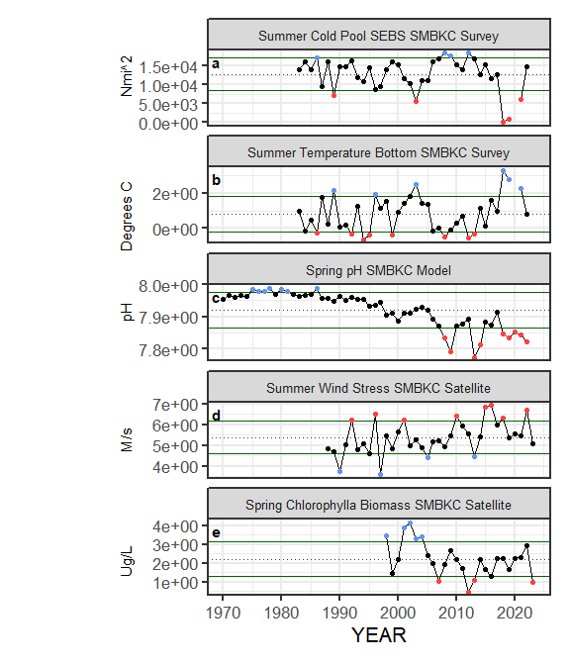

##### Figure ??. Selected ecosystem indicators for Blue King Crab with time series ranging from 1970 – present. Upper and lower solid green horizontal lines are plus and minus one standard deviation of the time series mean. Dotted green horizontal line is the mean of the time series.

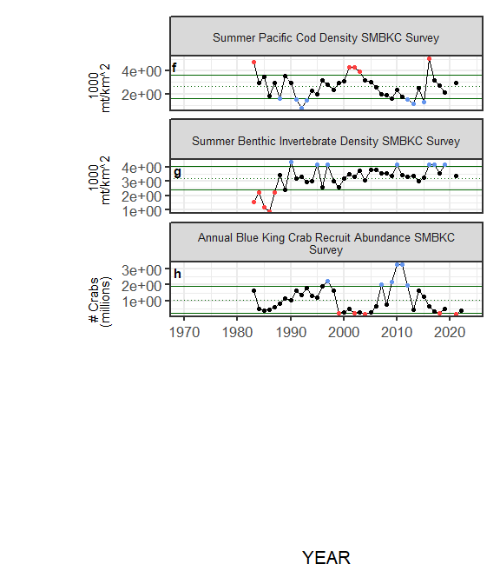

##### Figure ??. Selected ecosystem indicators for Blue King Crab with time series ranging from 1970 – present. Upper and lower solid green horizontal lines are plus and minus one standard deviation of the time series mean. Dotted green horizontal line is the mean of the time series.

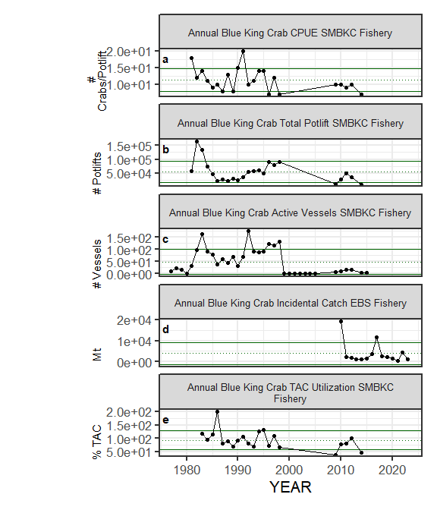

##### Figure ??. Selected socioeconomic indicators for Blue King Crab with time series ranging from 1970 – present. Upper and lower solid green horizontal lines are plus and minus one standard deviation of the time series mean. Dotted green horizontal line is the mean of the time series.

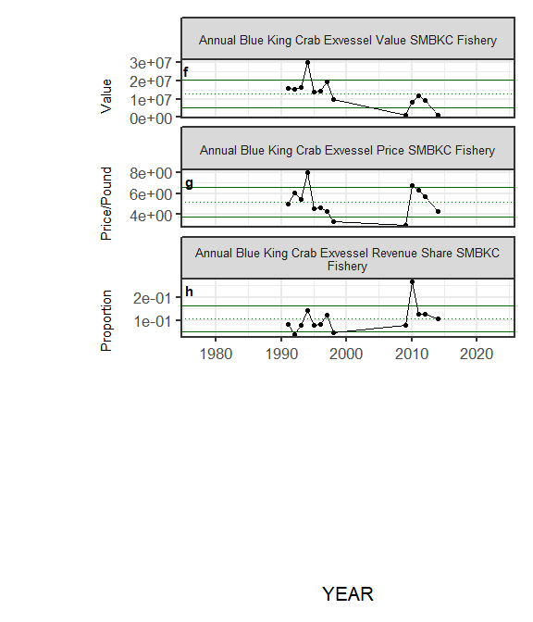

##### Figure ??. Selected socioeconomic indicators for Blue King Crab with time series ranging from 1970 – present. Upper and lower solid green horizontal lines are plus and minus one standard deviation of the time series mean. Dotted green horizontal line is the mean of the time series.

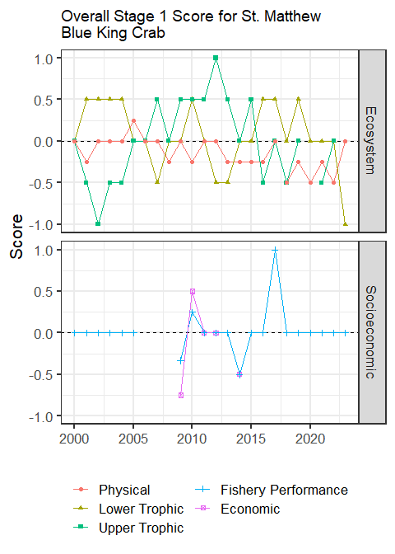

##### Figure 6. Simple traffic light score for overall ecosystem and socioeconomic categories from 2000 to present.



##### Figure 7. Bayesian adaptive sampling output showing (a) standardized covariates prior to subsetting and (b) the mean relationship and uncertainty (95% confidence intervals) with log Blue King Crab recruitment, in each estimated effect (left bottom graph), and marginal inclusion probabilities (right bottom graph) for each predictor variable of the subsetted covariate set